

SAVEETHA SCHOOL OF ENGINEERING

SAVEETHA INSTITUTE OF MEDICAL AND
TECHNICAL SCIENCES

DEPARTMENT OF COMPUTER SCIENCE AND ENGINEERING

LIST OF EXPERIMENTS

COURSE CODE : CSA4001
COURSE NAME : MANAGEMENT INFORMATION SYSTEM

4 Draw a UML diagram for ATM System using CASE tool. The banking system allows a customer to access the financial transactions by ATM System, it has a step-by-step process describe the work of this process and elaborate the what are the work can do by customer, banking system, administrator and technicians with the ATM system.

AIM:
To design a UML Diagram for an ATM System using a CASE tool, illustrating the interactions between Customers, Banking System, Administrator, and Technicians with the ATM.

PROCEDURE:
• Customer Transactions
- Customers log in using an ATM card and PIN.
- They can perform transactions such as:
  - Withdraw Cash
  - Deposit Cash
  - Check Account Balance
  - Transfer Funds
  - Print Mini Statements
- Customers log out after completing their transactions.
• Banking System Operations
- Manages customer accounts.
- Verifies transactions and security checks.
- Approves or declines transactions based on available funds and security policies.
• Administrator Tasks
- Monitors ATM usage and transaction reports.
- Configures ATM settings and updates software.
- Manages user accounts and access privileges.
• Technician Responsibilities
- Maintains ATM hardware and software.
- Refills ATM cash and receipt paper.
- Fixes errors, malfunctions, and connectivity issues.

OBSERVATION:

USECASE DIAGRAM:
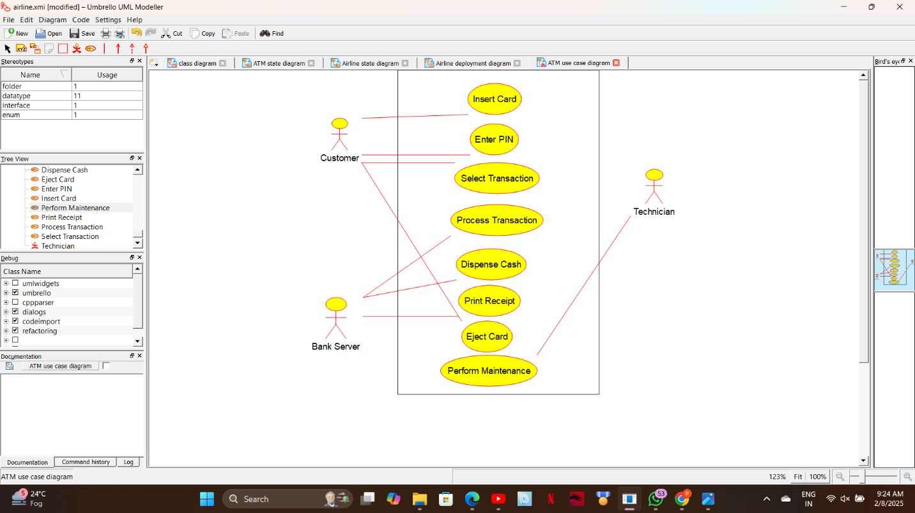

CLASS DIAGRAM:
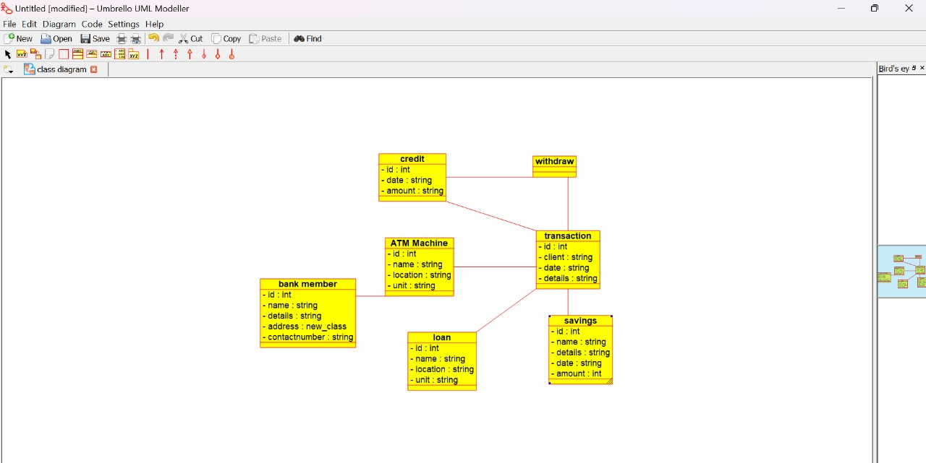

ACTIVITY DIAGRAM:
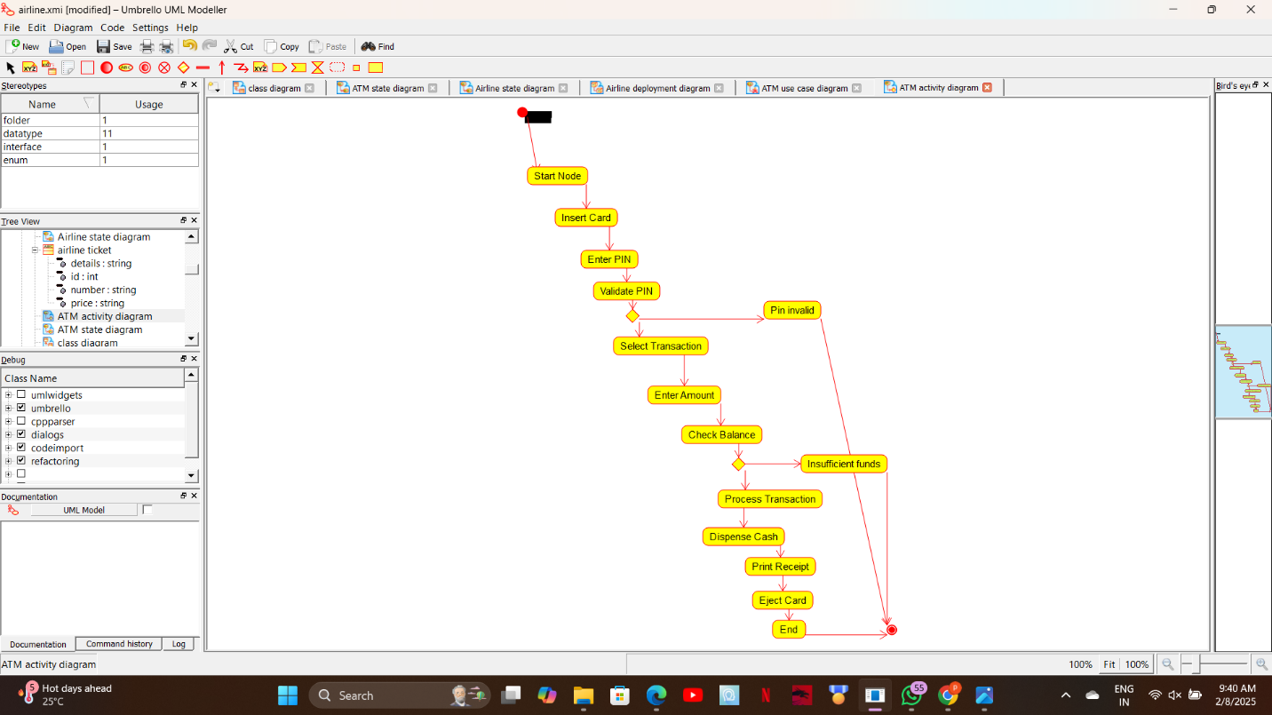

STATE DIAGRAM:
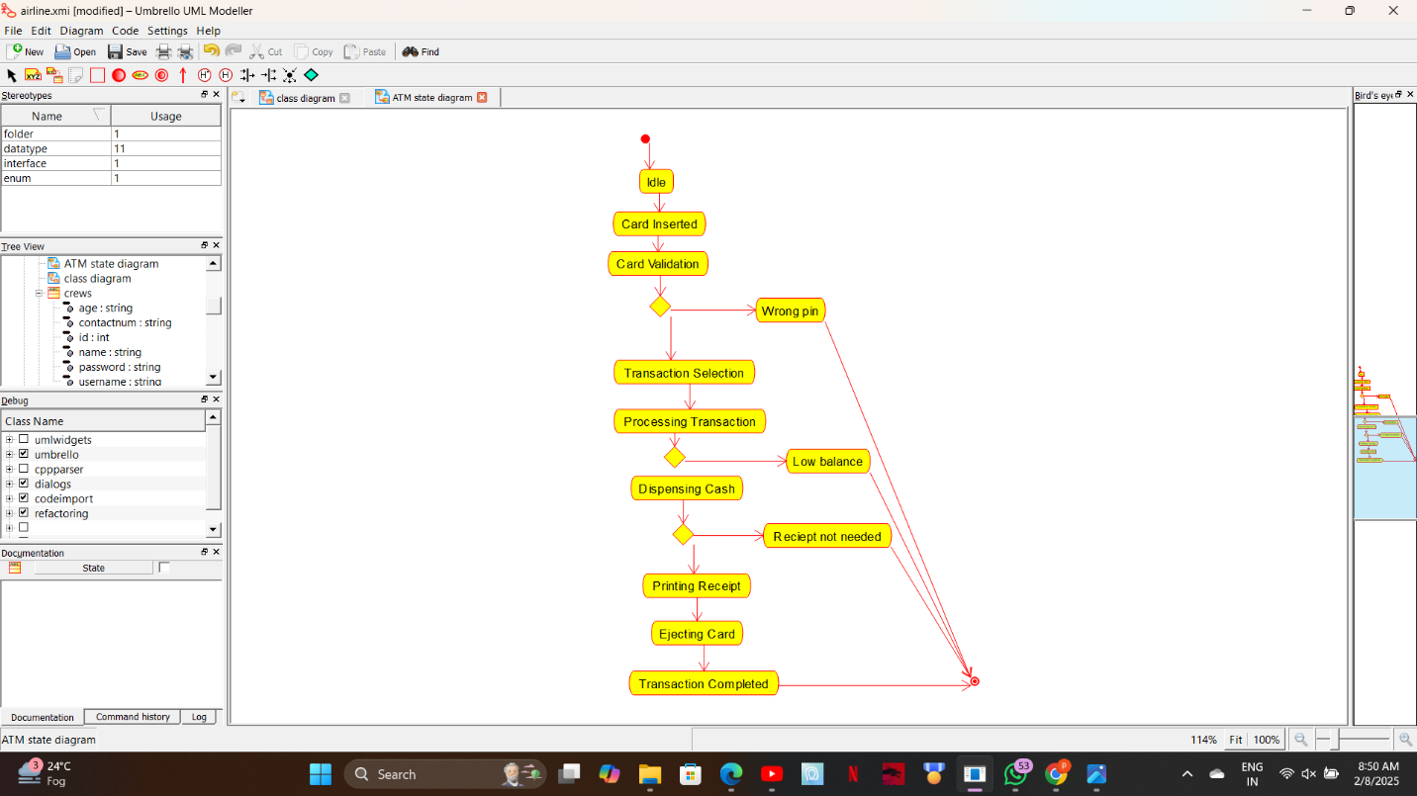

COMMUNICATION DIAGRAM:
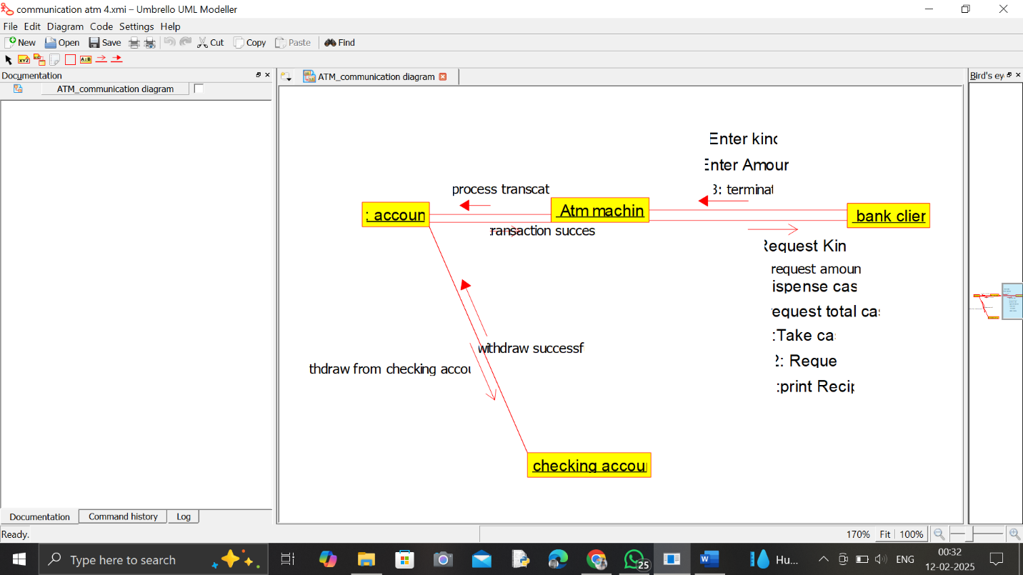

SEQUENCE DIAGRAM:
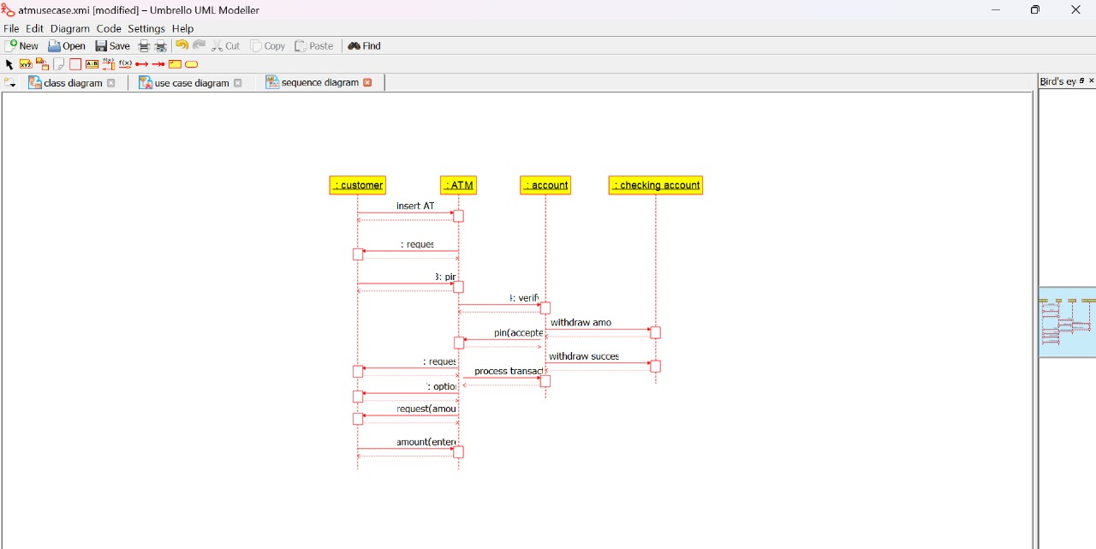

COMPONENT DIAGRAM:
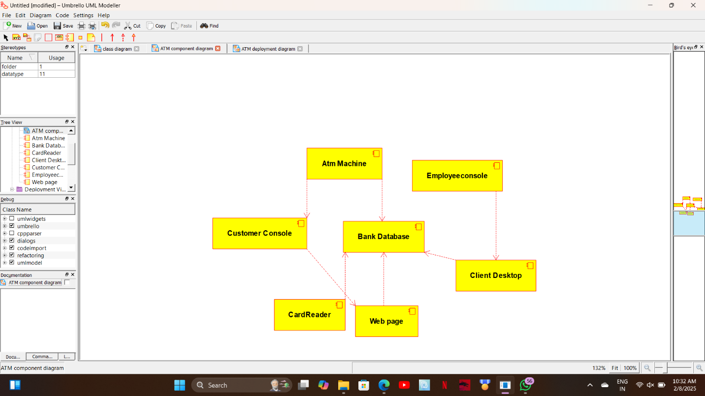

DEPLOYMENT DIAGRAM:
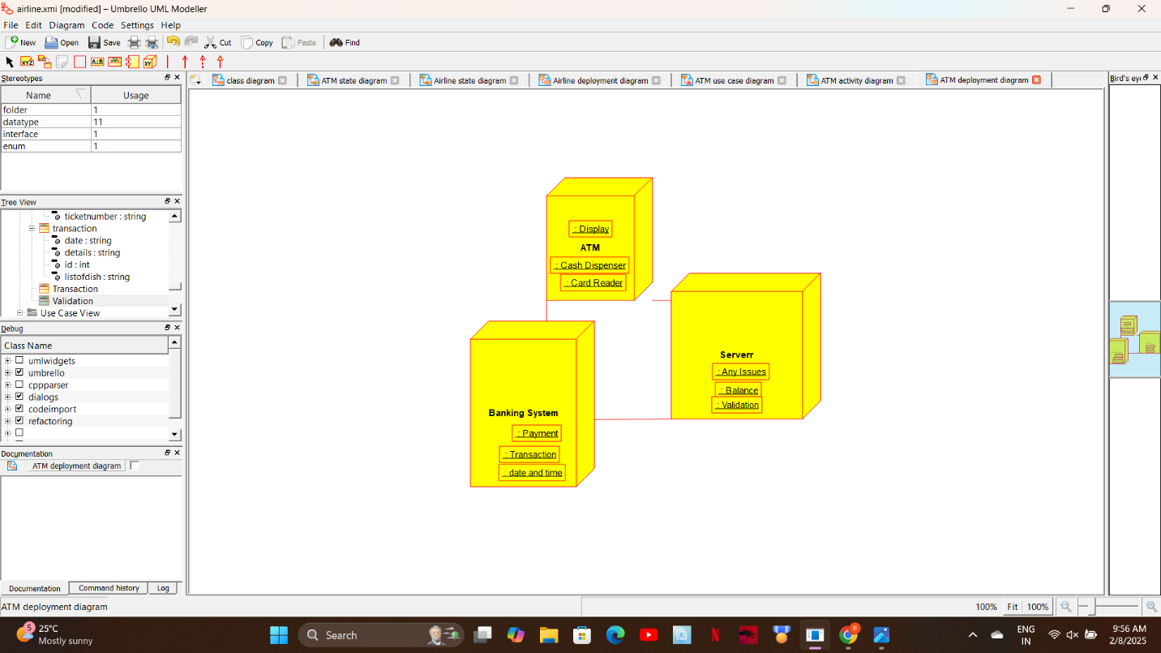

ER DIAGRAM:
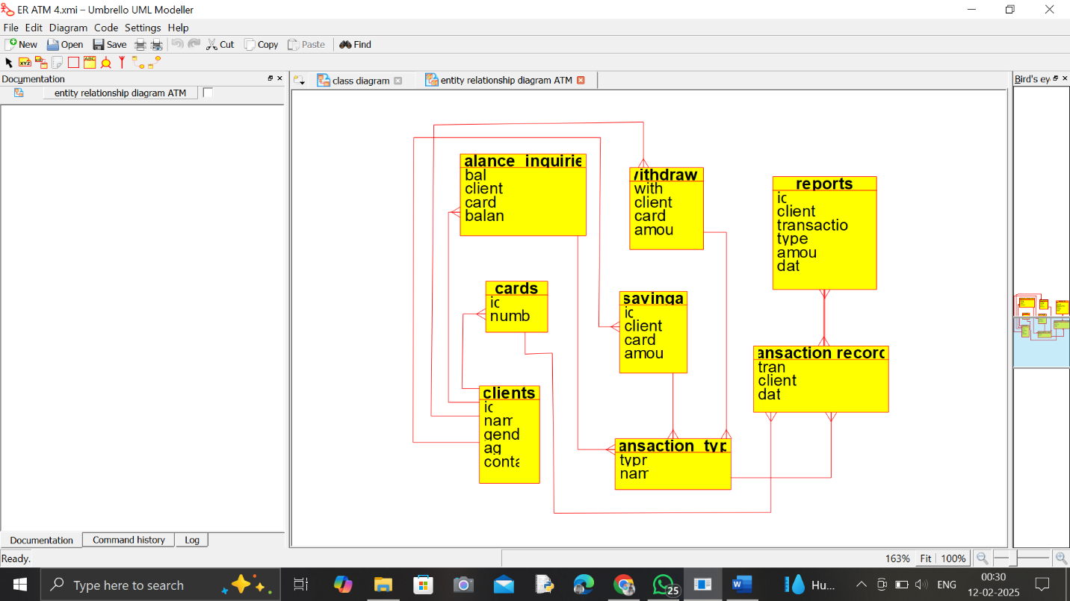

RESULT:

The UML Diagram for the ATM System has been successfully created, illustrating the interactions between Customers, Banking System, Administrator, and Technicians with the ATM.

